A picture containing clipart

Description generated with very high confidence

Azure 103 Module 5

Hands On - 3

Azure Certification Training

[**support@intellipaat.com**](mailto:support@intellipaat.com)

**+91-7022374614**

**US: 1-800-216-8930(Toll Free)**

**Azure 103 Module 5 Hands On – 3**

**Set up VPN Gateway Site to Site Connection**

**Step 1:** Search for Local Network Gateway in Azure portal and click on it.

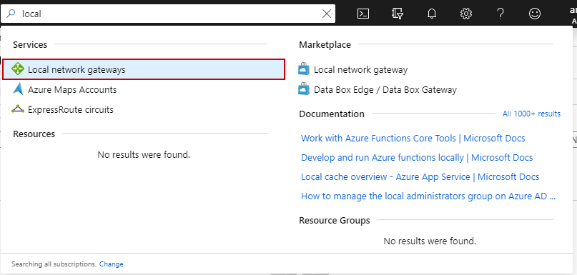

**Step 2:** Click on + Add.

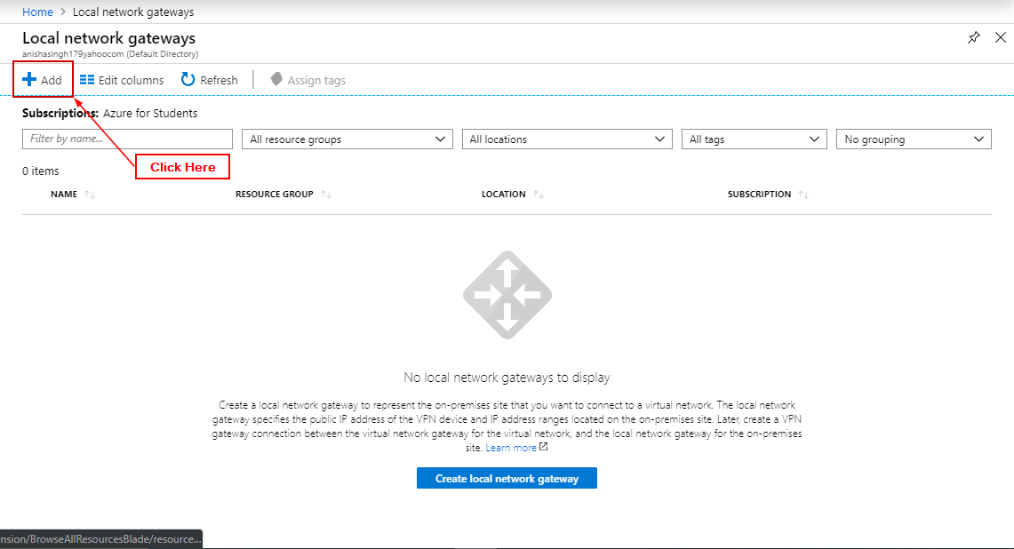

**Step 3:** Enter details and click ‘Create’.

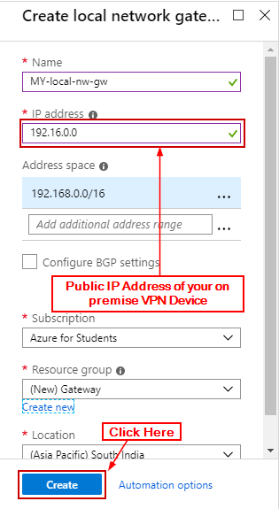

**Step 4:** Search for Virtual Network Gateways and click on it.

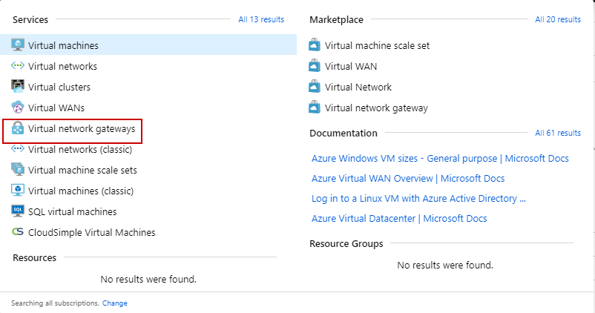

**Step 5:** Click on ‘+ Add’.

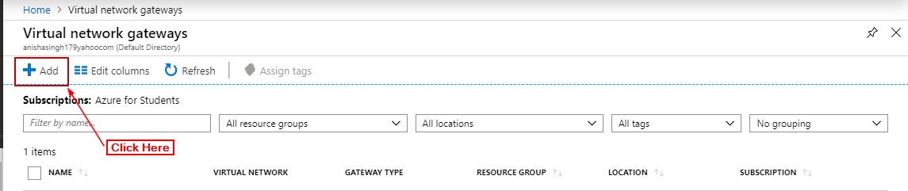

**Step 6:** Open the Virtual Network Gateway and click on Connections and click on Add.

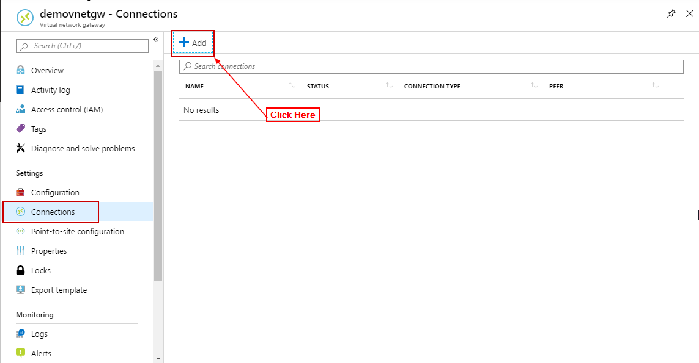

**Step 7:** Add the details and click on ‘OK’.

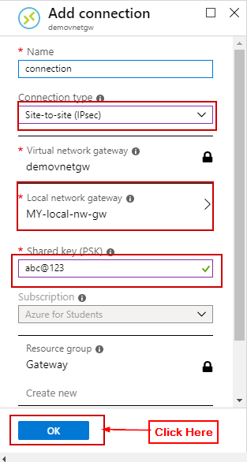

**Step 8:** Open the connection and click on download configuration. Fill in the details of your VPN device and click on ‘download configuration’.

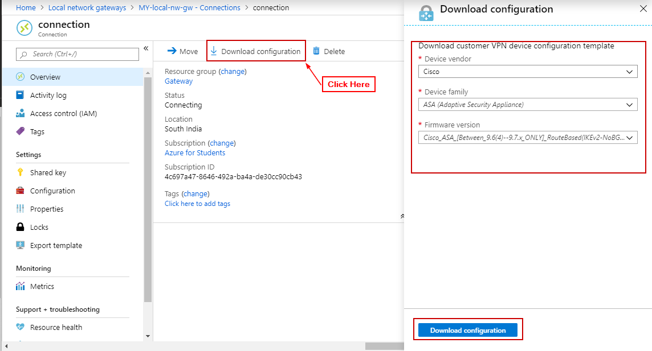

**Step 9:** Open the configuration script with a text editor and search for the keyword "REPLACE" to identify and examine the parameters that may need to be replaced.

**Step 10:** Apply the configuration script to your VPN device. The actual steps to apply the script varies from device to device so you’ll have to check your devices instruction manuals.

